|  |
| --- |
| University Of tennessee Department of Nuclear Engineering |
| Low-Enriched High Temperature Gas Cooled Reactor |
| Group Design Project |
|  |
| ***Authors***:  Trey Huffine  Travis Owens  Ian Stewart  Alex Popova  Kyle Fletcher  Drew Hall |
| 4/30/2013 |

Dr. Martin Grossbeck, Faculty Advisor

|  |
| --- |
|  |

**Abstract**

Very High Temperature Reactor (VHTR) Systems are gaining interest in recent years as increased research is underway to develop safer, more efficient, and emission free advanced reactors. This design implements a pebble bed fuel design measuring 6.0cm radius using UCO filled TRISO fuel particles. The reactor core resides 8.5m tall with a radius of 1.75m and is filled with approximately 8.95E5 fuel pebbles. The pebbles are designed with a BeO layer for further moderation to slow the neutrons into the thermal region. 55cm silicon carbide reflectors are utilized immediately surrounding the reactor core to increased neutron economy within the core. Helium is used as the primary coolant and is pressurized to 3atm in order to lower the fuel enrichment required. By setting the power of the reactor to 1000MWth, an enrichment of 5% yields a keff of around 1.05 through the program SCALE6.1.

**Acknowledgements**

The authors would like to express their sincere appreciation to all who contributed to the completion of this project. First we would like to hugely thank Dr. Martin Grossbeck, our faculty advisor, for his invaluable input and assistance for the direction of our project. An extended thank you also goes to Dr. Arthur Ruggles for his patience in assisting our thermal analysis of the system. Dr. Ronald Pevey’s open-door policy for any and all questions we came across while implementing SCALE analysis. Much gratitude also goes to the University of Tennessee’s Nuclear Engineering Department Graduate students for their aid in programming portions of the project.

Table of Content

**Abstract** ..................................................................................................................................................... **i**

**Acknowledgements** ................................................................................................................................... **ii**

**Common Abbreviations** ........................................................................................................................... **v**

**List of Figure** ..............................................................................................................................................**vi**

**List of Figure** ............................................................................................................................................. **vi**

**Section 1: Introduction** ........................................................................................................................... **1**

* 1. **Background** ........................................................................................................................... **1**

**1.1a HTR-10 Reactor Design** ............................................................................................... **3**

**1.1b PBMR in South Africa** ................................................................................................. **3**

**1.2 Project Description** ............................................................................................................... **4**

**Section 2: System Design** ..........................................................................................................................**4**

**2.1 Reactor Core** .........................................................................................................................**4**

**2.1a Core Materials** ........................................................................................................ **5**

**2.2 Online-Refueling** .................................................................................................................... **8**

**2.3 Reflector Analysis** .................................................................................................................. **8**

**Section 3: Fuel Analysis** ........................................................................................................................... **12**

**3.1 SCALE Simulation** ................................................................................................................ **17**

**3.1a SCALE 6.1 Sequences** ............................................................................................ **18**

**3.1b SCALE 6.1 Geometry**............................................................................................. **20**

**3.1c Doubly-Heterogenous** ............................................................................................ **20**

**3.1d Global Geometry** .................................................................................................... **22**

**3.1e Results and Analysis** .............................................................................................. **23**

**3.1f Reflector Thickness** ................................................................................................ **24**

**Section 4: Thermal Hydraulics** ............................................................................................................... **25**

**4.1 Primary Loop** ........................................................................................................................ **25**

**4.1a Thermophysical Helium Properties** ..................................................................... **26**

**4.1b Pressure Drop** ......................................................................................................... **27**

**4.1c Heat Transfer** ......................................................................................................... **32**

**4.1d Shutdown Heat Transfer** ....................................................................................... **37**

**4.2 Secondary Loop** ..................................................................................................................... **39**

**Section 5: Disadvantages** ......................................................................................................................... **43**

**Section 6: Economics** ............................................................................................................................... **45**

**Conclusions** ............................................................................................................................................... **46**

**Future Work** ............................................................................................................................................. **47**

**References** ................................................................................................................................................ **50**

**Appendix** ................................................................................................................................................... **55**

**Abbreviations**

*ACS*: Active Cooling System

*AVR*: Arbeitsgemeinschaft Versuchsreaktor (‘Association of Experimental Reactor’)

*CCS*: Core Conditioning System

*HTGR*: High Temperature Gas Reactor

*HTR-10*: High Temperature Reactor

*IAEA*: International Atomic Energy Agency

*IPyC*: Inner-layer Pyrolytic Carbon

*MATLAB*: Matrix Laboratory (Program)

*MIT*: Massachusetts Institute of Technology

*NEI*: Nuclear Energy Institute

*OPyC*: Outer-layer Pyrolytic Carbon

*PBMR*: Pebble Bed Modular Reactor

*PBR*: Pebble Bed Reactor

*PPB*: Primary Pressure Boundary

*PWR*: Pressurized Water Reactor

*RCCS*: Reactor Cavity Cooling System

*RPV*: Reactor Pressure Vessel

*SCALE*: Standardized Computer Analyses for Licensing Evaluation (Version 6.1)

*TRISO*: Tristructural-isotropic

*UTS*: Ultimate Tensile Strength

*VHTR*: Very High Temperature Reactor

**List of Figures**

Figure 1.1: Time-line and Corresponding Nuclear System Generation.

Figure 1.2: Pebble fuel particle implemented in PBR design.

Figure 2.1: Typical creep strength of INCOLOY alloy 800H.

Figure 2.2: Yield strength of SiC and how it compares to other materials

Figure 3.1: Illustration of the coated particle showing each layer and material

Figure 3.2: TRISO particle distribution in matrix material.

Figure 3.3: Solid beryllium oxide.

Figure 3.4: Sequence of CSAS5 computations using CENTRM with doubly-heterogeneous cell.

Figure 3.5: The structure of a micro cell created using DOUBLEHET.

Figure 3.6: The structure of a macro cell created using DOUBLEHET.

Figure 3.7: Plot of enrichment vs. keff.

Figure 4.1: Pressure drop with a varying core height and fixed radius of 1.73m.

Figure 4.2: Pressure drop with a varying core diameter and fixed height of 8.5m.

Figure 4.3: Pump power with a varying core height.

Figure 4.4: Pump power with a varying core diameter.

Figure 4.5: Pebble fuel sketch to be used for head transfer analysis.

Figure 4.6: Shows the centerline, surface, and bulk temperature in the core.

Figure 4.7: Shows the centerline temperature with variable pebble radius.

Figure 4.8: Depicts the heat transfer under a shutdown situation.

Figure 4.9: Typical Brayton Cycle P-v and T-s diagrams.

Figure 4.10: A typical Brayton Cycle with intercooling, and its T-s diagram.

Figure 4.11: A typical Brayton Cycle with reheating, and its T-s diagram.

Figure 4.12: Conventional regeneration cycle along with a T-s analysis.

Figure 5.1: Example of a defective pebble fuel particle.

Figure 6.1: Comparative monthly operation costs for U.S. Electric Utilities.

**List of Tables**

Table 1.1: Design data for China’s HTR-10 design.

Table 2.1: Reactor design data.

Table 2.2: Thickness core barrel required on varying pressures.

Table 2.3: A comparison of various reflector materials.

Table 3.1: Fuel grain composition and size specifications.

Table 4.1: Optimized core parameters implemented in design.

# Section 1: Introduction

**1.1 Background**

The current fleet of reactor systems is aging and a need for a more efficient and emission-free system is vital for future use. Nuclear reactor systems are divided into generations depending on the design and date in which the reactor was built. Each new generation attempts to increase the safety features and efficiency of the reactor system, while taking into account the economic factors of waste management, materials, and construction costs to decrease the overall expense of the plant. Figure 1.1 displays the time period of each nuclear reactor generation.

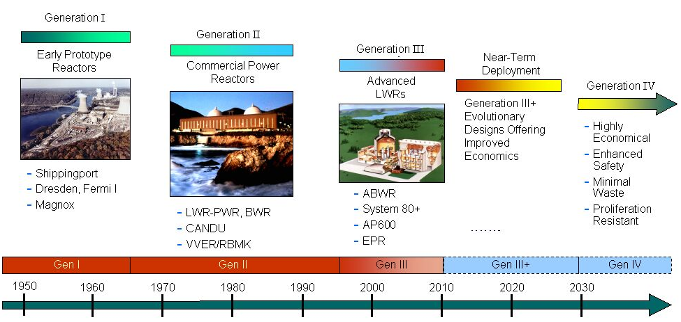

# Figure 1.1: Time-line and corresponding Nuclear System Generation. Argonna National Lab,1

A great deal of research is being applied in the next generation of nuclear systems. The VHTR (Very High Temperature Reactor) is a type of thermal reactor in this next generation of reactors, also known as Generation IV reactors. Governments (e.g. United States DOE, France, and China) and electric utilities are interested in this VHTR design due to several safety feature concepts, such as: higher heat capacity, lower power density, and passive heat removal due to natural circulation. The pebble bed design resides under this VHTR concept. The name of this design refers to the unique fuel shape, which resembles a pebble and is seen in Figure 1.2. 2

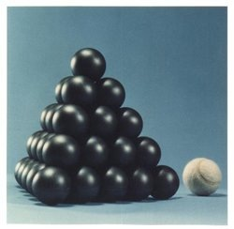

**Figure 1.2: Pebble fuel particle implemented in PBR design.** 3

Another notable change from the Generation III reactor for the HTGR is the coolant being in a gaseous state. An inert gas is used (e.g. helium or carbon dioxide) as the primary coolant, which allows for higher temperatures to be reached compared to the more conventional water cooled designs. The higher temperature also allows for a higher plant efficiency to be obtained (~40%). 4

Another objective for the high-temperature reactor design is hydrogen production. The primary use of the hydrogen at the present time is for gasoline conversion from crude oils. Hydrogen can be separated from water through electrolysis or thermochemical cycles, which is discussed in more detail later. This process has the potential to add additional costs to the facility, but can also lower the global prices of petroleum products.

**1.1a HTR-10 Reactor Design**

At the Tsinghua University in China, a PBMR (Pebble Bed Modular Reactor) was designed and began construction in June 1995. The university reached full operation of the reactor in January of 2003. This HTR-10 reactor, as it was named, is a 10MW prototype used for research at the university.5 China is interested in the modular design due to the faster construction time and overall economic value. The objective of HTR-10 research reactor was to verify the safety and technical features of the design for later use on the power grid.6 The design criteria and data are tabularized below in Table 1.1.

**Table 1.1: Design data for China’s HTR-10 design.** IAEA-TECDOC-1198

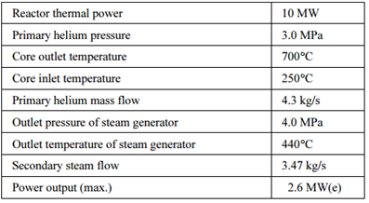

**1.1b PBMR in South Africa**

The PBMR in Koeburg, South Africa was announced in June 2004 as a government owned system. Approval of the construction was to begin in mid-2005 to develop a 116.3MWe demonstration reactor.7 The funding for the project ceased a few years later due to national opposition from the public and interest groups.8 In September of 2010, the Minister of Public Enterprises in South Africa officially closed the PBMR site, where the facility was to start immediate decommissioning. 9

Both pebble bed reactor projects used a gas-cooled design, implementing helium as a coolant as well as to moderate the neutrons and not to react chemically with any of the materials within the reactor core. A TRIstructural-ISOtropic (TRISO) fuel particle was used within the fuel pebble in both project designs. For further moderation and neutron reflection, graphite was implemented in the reactor cores and pebble materials.

**1.2 Project Objectives**

The project objectives of this design project were to research and design a conceptual reactor system that operates at high temperature ranges and achieves high efficiency power generation. Analysis of the materials used within the system (e.g. reflectors, fuel, moderators, etc.) was required to accurately represent the system. Computer code and programs were also to be implemented to model the reactor system (e.g. MATLAB, SCALE). Finally, process heat of the reactor system was to be used for industrial processes, such as hydrogen production.

**Section 2: System Design**

**2.1 Reactor Core**

The concept of this reactor is to create a HTGR (High Temperature Gas Reactor) that transforms the standard design to one that will allow for low fuel enrichment, while still being able to produce electricity and create hydrocarbon fuels. This design utilizes a pebble bed core cooled by helium gas pumped through the bottom of the reactor. A screen resides on top of the core to eliminate pebble fuel floating. The core barrel housing the pebbles is made of INCOLOY alloy 800H. In addition, the helium piping is also made of the same INOCOLOY alloy 800H. Immediately surrounding the core barrel is a reflector made entirely of silicon carbide. Several variables have been changed to optimize the fuel enrichment, including: core dimensions, reflector materials, helium density, and pebble dimensions. The manipulation of these parameters will then affect the required pressure drop, number of pebbles in the core, and the operating temperatures. Table 2.1 shows the optimized operating parameters in the design. The lifetime of the reactor design was decided for 40 years.

**Table 2.1: Reactor design data.**

|  |  |
| --- | --- |
| **Reactor Design** | |
| Height (m): | 8.5 |
| Radius (m): | 1.75 |
| Reactor Power (MWt): | 1000 |
| Coolant: | Helium |
| Reflector: | Silicon Carbide |
| Containment: | INCOLOY Alloy 800H |
| Fuel: | Pebbles, TRISO |

**The height and radius chosen for the design were assumed from a standardized PBR design used from IAEA analysis.**,6 IAEA

**2.1a Core Materials**

One of the primary concerns with the HTGR system is finding suitable materials capable of withstanding the temperature and pressure conditions inside of the reactor over long exposure period. The material chosen for the piping and core barrel is INCOLOY alloy 800H which is an alloy composed of iron, nickel, chromium, carbon, aluminum, and titanium. INCOLOY alloy 800H is well suited to handle the elevated temperature over extended periods of time, and its properties are widely used in the production of hydrogen. In addition, the alloy 800H has a melting point range of 1357-1385 ͦ C, significantly higher than the temperatures achieved by our reactor under normal operating conditions.10, p.3

One of the primary characteristics to be analyzed for the reactor materials is the creep behavior. Since the material will be exposed to temperatures approaching 1000 ͦ C, thus the alloy must have a suitable reactor vessel thickness in order to not fail during the lifetime of the reactor. The following equation 2.1 is used to evaluate the necessary reactor thickness.10

........................................................................ (Eq. 2.1)

Where: t = thickness

P = pressure

D = diameter

= hoop stress

The mechanical analysis will be conducted at a temperature of 870 ͦ C, which is a conservative approach because it will encompass all operating conditions. Creep is calculated at a 40 year lifetime of the design for a 1% deformation. The data will have to be extrapolated to calculate a deformation this low over such a large lifetime. Figure 2.1 shows the creep strength diagram utilized to analyze INCOLOY alloy 800H.10, p.7

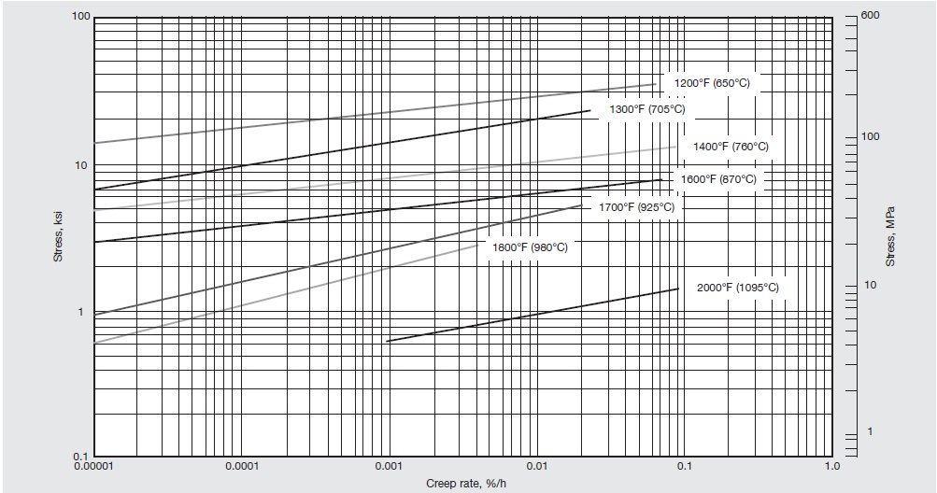

**Figure 2.1: Typical creep strength of INCOLOY alloy 800H.10**

The creep of 1% yielded at our operating temperature yielded a hoop stress of 10.5 MPa. Performing a computer simulation of the creep behavior for a 40 year reactor lifetimes and various operating pressures yielded the results for thickness shown in Table 2.2. Helium pressure will be discussed in preceding sections of the paper.

**Table 2.2: Thickness core barrel required on varying pressures.**

|  |  |
| --- | --- |
| **Thickness (m) for a 40 year lifetime** | |
| 1 atm pressure | 0.01241 |
| 2 atm pressure | 0.0483 |
| 3 atm pressure | 0.0724 |

**2.2 Online-Refueling**

The pebble bed design can be refueled while the reactor system is online, thus giving no need to shut down the reactor as frequently (~18 months for LWR) previous generations of reactors. The pebble fuel flows through the reactor core and passes through the bottom, where measurements are made to calculate structural integrity and the fuel particle’s percentage of fissile material remaining. In the PBMR project in South Africa, scientists found that on average a pebble passes through the reactor about six times and lasts about 1000 days before a pebble needs to be replenished by a new fuel pebble. With no outages sprouting from the need to refuel the reactor, the outages are then to be scheduled by turbine generator maintenance, which is estimated to be around every 6 years for a PBMR.11

**2.3 Reflector Analysis**

Lowering the fuel enrichment will cause a reduction in the keff, and thus steps must be taken to increase the neutron economy of the core to still induce criticality at the lower enrichments. Thus, one of the ways to increase the amount of thermal neutrons in the core is to introduce a reflector immediately surrounding the INCOLOY Alloy 800H containing the fuel pebbles.

The ideal qualities of a reflector include a material that will not absorb neutrons, but will reflect or scatter the neutrons back into the core. In addition, it is desirable to have a reflector with a low atomic mass in order for the fission neutrons to lose a higher amount of energy on the scatters.12 Engineers examine several desirable qualities, such as: radiation stability, temperature stability, and resistance to oxidation. Silicon carbide (SiC) is an excellent candidate for all of these characteristics and is the chosen material for the reflector in the design.

One of the key characteristics of silicon carbide is that the material has high yield strength at the operating temperatures. Even though the reflector itself should not be under intense stresses, it is important to have a material that will not fail easily if stress is applied. Using Figure 2.2, SiC resides above graphite in yield strength through temperatures range of .

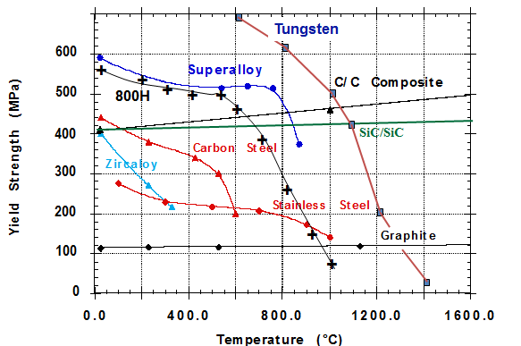

**Figure 2.2: Yield strength of SiC and how it compares to other materials.Wang,11**

Temperatures in the low enrichment HTGR will be above 800 ͦ C, thus need for a high yield strength is necessary to withstand the operating conditions. Silicon carbide ceramics with little or no grain boundary impurities maintain their strength to very high temperatures, approaching 1600°C with no strength loss.12

Next, silicon carbide’s irradiation stability must be considered. Irradiation stability is essential for a reflector material as it will encounter intense irradiation. Silicon carbide has excellent chemical and dimensional irradiation stability as indicated by the failure rate of less than 10-6 failure per lifetime in TRISO fuel analysis.14

After it has been decided that the material can withstand the radiation dose, the number of scatters and energy of the neutron after the scatter must be determined. To accomplish this task , the cross-section must be calculated. The nuclear densities for silicon and carbon will be the same since the mole ratio is one to one. First the nuclear density and macroscopic absorption cross section of silicon carbide is calculated using equation 2.2-2.3.

………...................…………………….. (Eq.2.2)

….. (Eq.2.3)

After the absorption cross section is found, it is necessary to find the scattering cross section shown in equation 2.4.

…...................................... (Eq.2.4)

The results show that silicon carbide is a usable material for the neutron scatter as a reflector.

In a reactor, the reflector will be subject to various contaminants in the coolants, and it must be certain that it will not oxidize under these conditions. Silicon carbide is not attacked by any acids or salts up to 800°C.16 However, if silicon carbide does oxidize, one oxidation product is silica, and silica actually acts as a stable protective layer. In order to minimize detrimental effects of the corrosion of silicon carbide, layers of environmental barrier coating (EBC) can be applied.17

To further understand silicon carbide, the logarithmic energy decrement, or moderating ratio, must be understood. It is desired to have the fewest number of collisions possible to thermalize a neutron. This means we must look past the scattering cross section, and into a materials thermalization efficiency. Neutrons produced in a fission reaction are around 2 MeV, and it is desirable to reduce their energy to .025 eV within the thermal energy range. Table 2.3 below shows the properties of silicon carbide and other reflector materials.

**Table 2.3: A comparison of various reflector materials.**

|  |  |  |  |  |
| --- | --- | --- | --- | --- |
| **Property** | **SiC** | **Berylliumc** | **Al-Alloyc** | **Graphitec** |
| Density (g/cc)b | 3.2 | 1.85 | 2.7 | 1.65-1.75 |
| Atomic Weight (g/mol) | 40.1 | 9.01 | 26.98 | 12.01 |
| Specific Heat (J/kgK)b | 750 | 1925 | 896 | 711 |
| Melting Point (K) | 3003.15 | 1558 | 855-925 | 3923 |
| Yield Strength (MPa) at 800°C | 400 | 186-262a | 55a | 120 |
| Absorption Cross Section (1/cm) | 0.00788 | 0.00123 | 0.0145 | 0.000321 |
| Scatter Cross Section (1/cm) | 0.312 | 0.865 | 0.0843 | 0.3854 |
| Moderating Ratio | 1.95 | 145 | 0.850 | 189 |

a – from Reference 14

b – at room temperature

c – assumed to be pure Be, Al, and C for cross section calculations

From Table 2.5, silicon carbide has the highest density out of the proposed reflector materials compared, and also the higher density (with a low atomic mass) makes the material an extremely desirable neutron reflector. Graphite is the only material with a higher melting point, but graphite has the potential to burn and has a significantly lower yield strength at increased temperatures. Furthermore, silicon carbide has an average to low absorption cross section and high scatter cross section. Silicon carbide has a very high moderating ratio as well, which is almost twice that of water. This is a desirable characteristic since water is commonly used and known to be a good reflector. Thus, overall, silicon carbide shows the best characteristics for a high temperature reactor reflector material.

**Section 3: Fuel Analysis**

Many configurations and compositions of nuclear fuel have been designed to serve various purposes. In a high temperature gas reactor, coated particle fuel has been proven to be the most viable option. The first coated particle fuel was used in England’s Dragon HTGR in the 1960’s, and since then has been the primary fuel choice for HTGR’s.18

Currently, the standard TRISO coated fuel particle design consists of a UO2 fuel kernel surrounded by a porous carbon layer, an inner layer of pyrolytic carbon, a layer of silicon carbide, and an outer layer of pyrolytic carbon. The finished coated particles are approximately 800 to 900 microns in diameter.19 Figure 3.1 below shows the configuration of the layers in a TRISO particle.

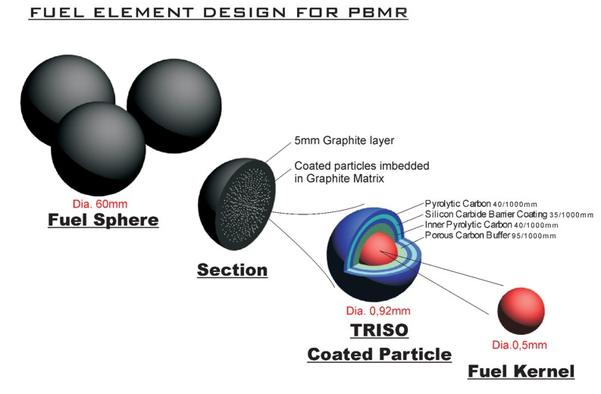

**Figure 3.1: Illustration of the coated particle showing each layer and material.**INL/EXT-10-17997

The innermost layer is the fuel kernel, typically composed of UO2. The next layer is a porous layer of carbon, which serves to accommodate the storage of fission gases produced during irradiation. The inner layer of pyrolytic carbon (IPyC) prevents Cl2 and HCl from permeating the porous carbon region during the fabrication process. It also provides a smooth, regular surface to which the SiC can be applied. The SiC layer is the primary structural component, serving as the wall of the pressure vessel formed by the build-up of fission gases in the porous carbon region. The outer pyrolytic carbon layer (OPyC) will shrink during irradiation, providing more structural stability by pre-stressing the SiC layer.

One of the main concerns in the manufacture and safe use of coated particle fuel is the buildup of gases inside the fuel particles. One of the ways this threat can be lessened is by using a stoichiometric two-phase mixture of UO2 and UC2 (UCO). The presence of carbon in the fuel will consume any oxygen atoms that are freed by the fission of UO2. This would prevent the formation of CO in the carbon buffer layer. The production of CO in the buffer would greatly increase the pressure level inside the particle, and could also cause the fuel kernel to drift away from its centered position in the TRISO coating.20

Another reason for the prevention of oxygen escaping the fuel kernel is to ensure that the rare earth elements are oxidized, and thus ismmobilized. This prevents them from reacting with the SiC layer.

The benefits of using UCO in the fuel kernel would be realized primarily at high burn-ups, when a particle has the potential to have developed a significant amount of CO buildup in the carbon buffer layer. The stresses experienced by the SiC due to this CO buildup can be approximated with a simple model. Assuming the pressure from fission gases and CO is contained solely by the SiC layer, the stress on the SiC can be approximated in equation 3.1 as:

............................................................................ (Eq. 3.1)

Where r is the radius of the SiC layer, P is the pressure on the SiC layer, and t is the thickness of the layer.

Since the internal pressure is due entirely to fission gases from uranium and from CO production, the pressure PTotal is expressed in equation 3.2.

PTotal = PKr + PXe + PCO .................................................... (Eq. 3.2)

Equation 3.1 can then be rearranged to give an expression for the maximum allowable internal pressure in a fuel particle, as shown below in equation 3.2.

........................................................ (Eq. 3.3)

Where PMax is the pressure at failure, UTSSiC is the ultimate tensile strength of SiC (350 MPa), t is the thickness (~35 microns), and r is the radius (~310 microns).

Solving for the pressure gives a value of 790 atm. This would mean that fuel designers could not allow more than ~300 atm of internal pressure in order to keep a high factor of safety, assuming that all particles are manufactured without flaws in the SiC layer. However, if CO production is significantly reduced, as when using UCO fuel, the most significant contributor of internal pressure is nearly eliminated. An additional way to significantly improve fuel performance under high pressures is to increase the thickness of the SiC layer.

The TRISO particles are dispersed in a pebble made of moderator material, as shown in Figure 3.2 below. Many current pebble designs use graphite as a matrix material due to its effectiveness as both a neutron moderator and a structural material. However, the use of graphite also poses a safety threat in that a graphite pebble at high temperatures, if exposed to oxygen, could ignite.

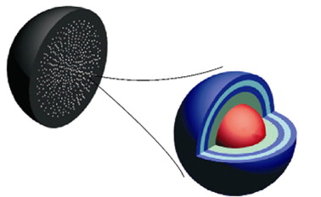

**Figure 3.2: TRISO particle distribution in matrix material.**Makhijani/Boyd, 21.

For the purposes of neutron moderation and high temperature stability a beryllium oxide matrix/moderator material would be superior to graphite. Beryllium has a much higher cross section for fast spectrum neutrons, and can also be manufactured to much higher densities than graphite. This BeO material has a high moderation compared to graphite, as well as an extremely high melting point, thus extremely unlikely to melt.21 Figure 3.3 below shows solid BeO manufactured into various shapes.

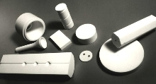

**Figure 3.3: Solid beryllium oxide.**ThomasNet,22.

In addition to improved moderation, a beryllium oxide matrix would not react with oxygen in the event of air ingress. This would protect against the possibility of the pebbles igniting, as well as preventing the production of carbides inside the reactor. Yet another advantage BeO possesses over graphite is that being a ceramic material, it has immense compressive strength, and would therefore be an exceptional structural material. This compressive strength would allow for higher helium pressures, and thus higher density of helium and better moderation.

The use of UCO fuel in an otherwise standard TRISO fuel configuration would extend the life of the fuel particles by preventing buildup of CO in the carbon buffer layer and immobilize rare earth oxides, thereby reducing the amount of contaminants in the reactor. Employing BeO as a matrix material would eliminate the risk of reaction with oxygen, significantly increase neutron moderation in the matrix and provide superior structural integrity, allowing for more neutron moderation by the helium coolant.

**3.1 SCALE Simulation**

SCALE 6.1 was used to analyze different reactor scenarios in order to achieve an appropriate keff that could be used at the startup of the reactor system at low enrichments. SCALE 6.1 code package is a comprehensive modeling and simulation suite for nuclear safety analysis and design that is developed and maintained by Oak Ridge National Laboratory (ORNL).23 This reactor model contains a cylinder housing homogenized fuel pebbles and helium contained by a silicon carbide reflector. The reflector was then covered with a thin layer of stainless steel with concrete surrounding the entire structure. This basic model was manipulated to experiment with varying reflector thicknesses, helium density, and pebble characteristics to reduce fuel enrichment. The rest of this section describes the Scale 6.1 sequences, geometry, and experiments conducted using SCALE 6.1 software.

**3.1a SCALE 6.1 Sequences**

SCALE 6.1 implements programs known as functional modules on a given input to perform specific tasks. A control module must first be selected to determine input format and the sequence of functional modules performed. The control module for enhanced Criticality Safety Analysis Sequences (CSAS5) was used for this project. CSAS5 was chosen because of its strong ability to calculate the best system keff along with its easy to use geometry construction due to KENO V.a. One aspect of the control module is the Material Information Processor Library (MIPLIB), which creates a problem-dependent cross section library for use by SCALE 6.1 control module. CENTRM, or continuous energy transport module, was the MIPLIB chosen due complex nature of the fuel cells and the need to implement a unit cell specification for doubly-heterogeneous (DOUBLEHET) cells. CENTRM uses approximations of the Boltzmann transport equation in one-dimensional or infinite media geometry to compute “continuous-energy” neutron spectra.23 The workflow of sequences performed during a SCALE 6.1 computation can be found in Figure 3.4 below.

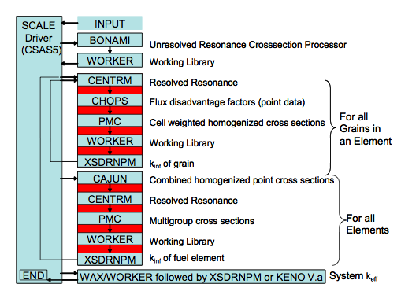

**Figure 3.4: Sequence of CSAS5 computations using CENTRM with a doubly-heterogeneous cell.**Scale6.1 Manul

The model created for this project was constructed using KENO V.a., which is a three-dimensional Monte Carlo criticality transport program that is implemented at the end of the computational sequence. In CSAS5, KENO V.a is used to calculate a system keff. KENO 3D also provides a three-dimensional visualization of the problem geometry as demonstrated in Figure 3.7 later in the report 23

**3.1b SCALE 6.1 Geometry**

The geometrical model was created using KENO V.a. This simple model contains a cylinder composed of pebbles, helium, a SiC reflector, and a stainless steel casing. The reactor is then housed in concrete. The fuel region consists of layered fuel grains contained within pebbles, which are then stacked in a triangle-pitch lattice with a helium moderator. This complex fuel region was modeled using DOUBLEHET.

**3.1c Doubly-Heterogeneous Cells**

TRISO fuel pebbles are modeled in KENO V.a using a unit cell specification known as DOUBLEHET. DOUBLEHET requires CENTRM to be chosen as the primary MIPLIB as DOUBLEHET creates cell-weighted fuel mixture from grain mixtures that are result in an invalid input for the continuous energy mode in KENO V.a.23

After implementing DOUBLEHET, the user must define the parameters of the micro and macro cells. The micro cells are fuel grains, which in this case are TRISO fuel grains. These grains contain Uranium Oxide surrounded by four different material coatings. The materials used along the corresponding relative thicknesses are in Table 3.1.

**Table 3.1: Fuel grain composition and size specifications. The materials are listed from the inside to outside.**

|  |  |  |
| --- | --- | --- |
| Layer | Material | Radius (cm) |
| Fuel | UO2 | 0.02985 |
| Coating 1 | Graphite | 0.03588 |
| Coating 2 | IPyC | 0.038945 |
| Coating 3 | SiC | 0.041835 |
| Coating 4 | OPyC | 0.04645 |
| Moderator Matrix | BeO | N/A |

Figure 3.5 below shows a visual representation of the micro cells, or fuel grains created using the DOUBLEHET command.

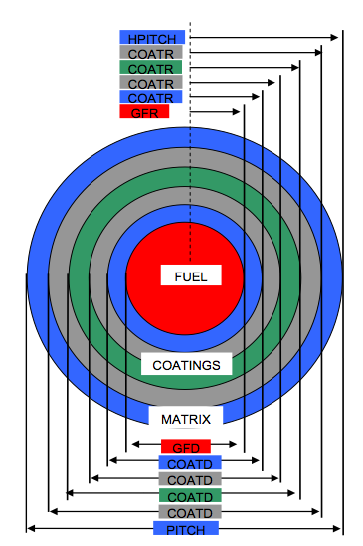

**Figure 3.5: The structure of a micro cell created using DOUBLEHET.**

Once the fuel grains have been created, one must specify the macro cell data. For this design, the macro cells represent the fuel pebbles to be placed inside the reactor vessel. Pebbles were constructed using beryllium oxide as a moderator instead of graphite. The fuel zone inside the pebble has a radius of 2.5 cm with no gap between the fuel zone and the cladding. The radius of the beryllium oxide cladding extends 3.5 cm further than the fuel zone, bringing the overall radius of the pebble to be 6.0 cm. The pebbles are then arranged in a triangular-pitch lattice, with a half-pitch of 3.6 cm. Figure 3.6 below shows a visual representation of the macro cells, or pebbles created using the DOUBLEHET command.

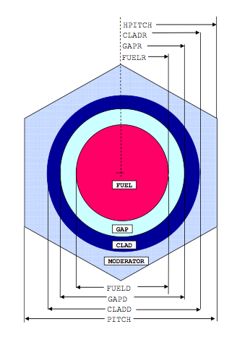

**Figure 3.6: The structure of a macro cell created using DOUBLEHET.**

**3.1d Global Geometry**

KENO V.a geometries must be constructed from the inside out, using simple geometric shapes (e.g. spheres, cylinders, or cuboids), where each shape created is called a unit. As new units are entered, they are created without disturbing the previously entered unit. This allows for the creation of a layered object, such as the cylindrical reactor vessel for this project. The reactor vessel created has an 8.5 meter tall fuel region with a radius of 1.75 meters. The fuel region is filled 7.5 meters high with the pebble cell lattice created using DOUBLEHET, while the gaps and top meter of the fuel zone is filled with helium. The fuel zone is surrounded by a 55 cm thick silicon carbide reflector, which is then encased in a 10 cm thick stainless steel coating and once again surrounded by concrete.

**3.1e Results and Analysis**

SCALE 6.1 was used specifically in this project to determine the effects of helium density, beryllium oxide pebble coating, and best reflector thickness to produce the lowest enrichment to be used in this high temperature gas cooled pebble bed reactor. The reactor vessel is placed in the same location, using the same materials, at the same temperature for each scenario conducted.

One of the primary features of this reactor is the ability to use lower fuel enrichment than other helium cooled pebble bed reactors. The goal of this design was to examine if naturally enriched fuel would allow for critical conditions under a reactor startup scenario. Using the reactor model previously described, various enrichments were inputted into SCALE 6.1 and the resulting keff were recorded. The uranium enrichments tested range from 1% to 20% enrichment. Figure 3.7 shows a plot of the enrichments tested and the resulting keff.

**Figure 3.7: Plot of enrichment vs. keff.**

According to the results, five percent enrichment can be used in this reactor to achieve a desirable start up keff  with the Helium coolant pressurized to 3 atm. Although higher enrichments provide higher reactivity, for economical reasons 5% enrichment is ideal due to higher costs for fuel enriching out-weighing the minuscule amount keff varied. Some factors that allow for such a low enrichment include: use of beryllium oxide as a moderator, increased helium pressure/density, and the core design specifications.

**3.1f Reflector Thickness**

Once the other parameters were determined, the ideal silicon carbide reflector thickness could then be calculated. Using the reactor model described earlier, the reflector thickness was analyzed. The reflector thickness was tested from 0 cm to 110 cm by increments of 5cm. Each scenario used a 10 cm thick stainless steel coating to surround the reflector. According to the results from SCALE6.1 code in the *Appendix*, the ideal reflector thickness is 55 cm. If the reflector width is decreased, the reactor will still achieve a supercritical keff at start up.

**Section 4: Thermal Hydraulics**

**4.1 Primary Loop**

One of the most attractive properties from an HTGR is the thermal efficiency of the system. The thermal hydraulics of the primary and secondary loops allows for a highly efficient energy conversion with the added benefit of increased safety features compared to current light water reactor designs. The thermal hydraulic analysis of the reactor includes the heat transfer from the fuel to the pebbles, the heat transfer from the pebbles to the helium, the pressure drop across the core, and the heat transfer to the secondary loop. These characteristics were analyzed and modeled through MATLAB code. As previously states, one of the key changes in the design of the core is that the fuel spheres will be made out of beryllium oxide instead of graphite. This proves to be very beneficial due to its thermal conductivity of 280 W/m-K, which is significantly higher than that of carbon.24

**4.1a Thermophysical Helium Properties**

Helium is generally accepted to be the best gas for a high temperature gas cooled reactor and was chosen to be the reactor’s primary coolant. Helium has excellent thermophysical properties as well as an extremely low neutron absorption cross-section and will not have an affinity to become activated. Thus, under an accident situation, there is no risk of leaking radioactive gas into the atmosphere.13 Since helium is a gas, its properties can vary depending on the core conditions. The thermophysical properties will be calculated according to the Danish Atomic Energy Commission data from their helium cooled reactor report. The mass flow rate of the helium will be an adjustable parameter depending on the necessary flow required to achieve the desired heat transfer and pressure results. The specific heat is considered to be a constant cp = 5193.1 J/(kg-K).

Equation 4.1 is used to calculate density in kg/m3, equation 4.2 is used to calculate the dynamic viscosity in kg/(m-s), and equation 4.3 is used to calculate the thermal conductivity of helium in W/(m-K).

………………………………. (Eq.4.1)

………………………………………. (Eq.4.2)

…………. (Eq.4.3)

Where: P = pressure, T = absolute temperature

**4.1b Pressure Drop**

The pressure drop across the core is dependent on many factors being tested in the analysis. These factors include the dimensions of the core, the packing of the spheres in the core, and the helium properties at the core conditions. These factors then directly correlate to the necessary pump power to operate at our desired conditions.26 Table 4.1 below shows the properties chosen for the low enrichment HTGR.

**Table 4.1: Optimized core parameters implemented in design.**

|  |  |
| --- | --- |
| **Optimized Reactor Core** | |
| Height (m): | 8.5 |
| Radius (m): | 1.75 |
| Sphere Radius (cm): | 6 |
| Pebbles | 8.95x105 |
| Reactor Power (MWt): | 1000 |
| Mass Flow (kg/s): | 2500 |
| Pressure Drop (kPa): | 12.29 |
| Pump Power (W): | 1.44x105 |

The dimensions of the core are paramount to the pressure drop across the core. The height of the core will directly affect the pressure drop and heat transfer capabilities. There must be a compromise between these two parameters with the ultimate goal of lowered fuel enrichment always as the primary concern. A core height of 8.5 meters was chosen to operate the reactor with power generation of 1000 MWth. This height will be used to find the mesh size in the numerical calculation and the total pressure drop. Likewise, the diameter of the core will affect the cross-section area and the mass flow through the core. This will in turn change the pressure drop through the core, which will become more apparent later.

Once the dimensions of the core have been optimized, they can then be used to calculate the volume of this core. The core volume in concurrence with the size of the fuel spheres can then be used to determine the number fuel spheres in the core by using the packing fraction. The core is assumed to be a homogenous matrix of fuel spheres surrounded by empty space occupied by the helium coolant. The space contained by the helium is known as the porosity and the space occupied by the spheres is the packing fraction. Equation 4.4 calculates the porosity and equation 4.5 calculates the packing fraction.27

…………..…………..……. (Eq.4.4)

Where: dp = diameter of the fuel pebble, Dreactor = diameter of the reactor

…………….…….…….….….…………. (Eq.4.5)

The packing fraction can then be inserted into Ergun’s equation to calculate the pressure drop due to the packing of pebbles. Equation 4.6 shows the equation that can be numerically solved to calculate the total pressure drop across the entirety of core.28

 ……….….…………. (Eq.4.6)

Where: μ = dynamic viscosity, v0 = superficial velocity

Dreactor = diameter of the core barrel, ρ = density of the helium

The commonly used equation for superficial velocity is calculated using equation 4.7 below.

……………….….…………. (Eq.4.7)

Equation 4.6 can be arranged and used in congruence with equation 4.7 to yield equation 4.8 which is in the form that can be solved numerically using the finite difference method.

 ………………. (Eq.4.8) 28

The pressure at the core of the low enrichment HTGR is . However, as various core dimensions were analyzed as the reactor was developed, it was necessary to see how the pressure drop would change with changes in the core height and radius. The core radius is fixed at 1.75 meters, and the height is varied. Then, the core height is fixed 8.5 meters, and the radius is varied. Figure 4.1 shows the pressure drop in the core with a constant core diameter and varying core height, and Figure 4.2 shows the pressure drop in the core with a constant core height and a varying core diameter.

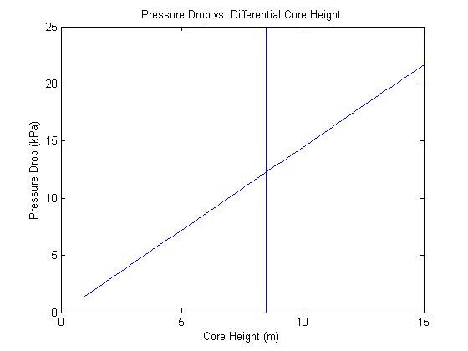

**Figure 4.1: Pressure drop with a varying core height and fixed radius of 1.75m.**

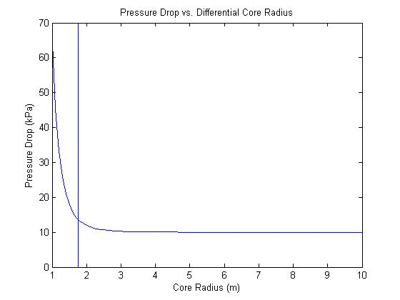

**Figure 4.2: Pressure drop with a varying core radius and fixed height of 8.5m.**

Once the total pressure drop across the core is calculated, it is necessary to calculate the pump power required to overcome the pressure drop. Similar analysis to the pressure drop can be conducted to find the changing power with the varying core height and diameter. The pump power percent of total thermal power for the low enrichment HTGR is .15%. Figure 4.3 shows the pump power as percent of total thermal power with a constant radius and varying height. Figure 4.4 shows the pump power as a percent of total thermal power with a constant height and varying radius.

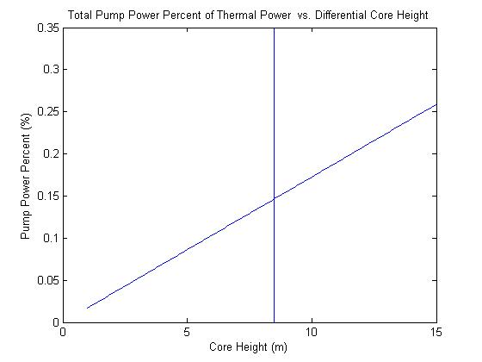

**Figure 4.3: Pump power percent of total thermal power with a varying core height. The chosen core height of 8.5m is illustrated in the figure as a vertical line.**

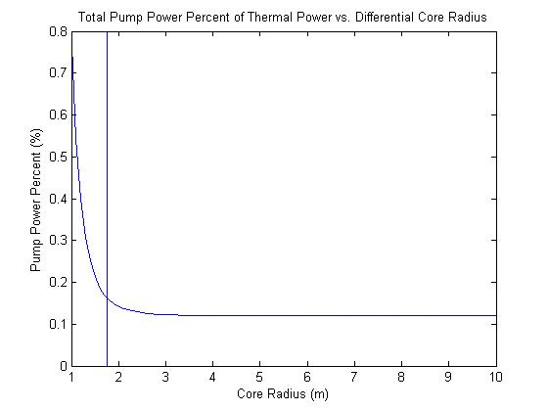

**Figure 4.4: Pump power percent of total thermal power with a varying core diameter. The chosen reactor core radius of 1.75m is illustrated as a vertical line in the figure.**

**4.1c Heat Transfer**

The goal is to create a low-enriched reactor that has a high enough temperature to produce electricity and hydrogen. In addition, it is essential to be able to ensure that the core will not reach a high enough temperature to melt any of the parts of the core. Some intensive research has already been conducted by various sources, and the results from the international conference held in China will be used as the benchmarks for the models of this report.29 Equation 4.9 is the basic heat transfer equation used.

……………….……………….…………. (Eq.4.9)

Which is rearranged to following equation 4.10:

……………….………….……. (Eq.4.10)

Where: Q = total reactor power, = mass flow rate of the coolant

cp = specific heat capacity of helium, T = bulk temperature

This equation can be solved using numerical methods. By breaking the reactor into an axial homogenous mesh, the incremental heat transfer can be calculated using the finite difference formula in MATLAB or other computer programming language. To do this, the reactor is broken down into cylindrical slices by using the cross-sectional area multiplied by the height of the current slice and then multiplied by the power of that current section. The equations will be derived and the temperature results from the numerical analysis code will be presented later in figure 4.7.

After the bulk temperature is calculated, the next step is to calculate the surface temperature of the pebbles. Understanding the surface temperature of the fuel is necessary to be able to ensure that the fuel will not melt under normal operating conditions. This is unlikely to occur even in a disaster situation, but the analysis is still implemented to increase the possibility of making HTGR’s a sincere possibility for commercial reactors. Equation 4.11 shows the equation that can be rearranged to calculate the surface temperature.28

………….….……. (Eq.4.11) Ruggles,28

Equation 4.11 can be rearranged and solved numerically using the finite difference method as seen below in Equation 4.12.

………………………. (Eq.4.12)

Where: = Differential core power generation, = differential height of core

h = heat transfer coefficient, Axs = cross-sectional area of the reactor

a = ratio of wetted surface to volume of the bed

Since the flow can either be laminar or turbulent, the Reynolds number must be calculated, which can then be used to calculate the correct heat transfer coefficient. Equation 4.13 shows the equation for the Reynolds number, .

…………………………………………. (Eq.4.13)

A Reynold’s number under 50x104 is laminar, while a Reynold’s number over 50 x104 is turbulent. Equation 4.14 shows the laminar equation, and Equation 4.15 shows the turbulent equation.

……………. (Eq.4.14)

.…………. (Eq.4.15)

Once the surface temperature of the fuel is calculated, it is possible to calculate centerline temperature of the core can be calculated. The centerline temperature is a function of the radius of the fuel and the radius of the beryllium oxide sphere. To be able to create a working model, the fuel inside the pebble will be assumed to be a homogenous sphere surrounded by a homogenous sphere of the beryllium oxide shell in a two region model, both being influenced by steady state conditions. Since different pebble sizes will be tested to see an increase in moderation to lower enrichment, a model with differential pebble diameter with constant fuel radius must be conducted. Figure 4.5 below shows the assumed pebble cross-sectional picture that is analyzed.

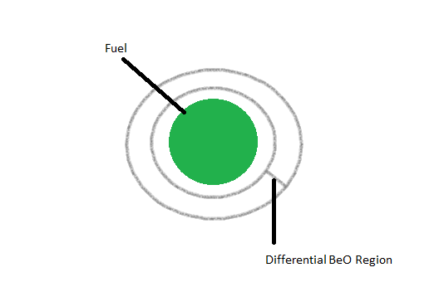

**Figure 4.5: Pebble fuel sketch to be used for heat transfer analysis.**

Equation 4.16 is the standard equation used to solve for the centerline equation. Solving the equation yields a maximum centerline temperature of 1031 ͦ C and an outlet bulk of 829 ͦ C, which is near the desired outlet temperature of 900 ͦ C while still using reasonable reactor parameters for the thermal hydraulics.

.…….…. (Eq.4.16)

Comparing this centerline temperature to the centerline temperature using graphite pebbles achieves drastically different results. Using graphite spheres yield a centerline temperature of 1198 degrees Celsius, around 130 degrees higher than beryllium oxide. It is obvious that beryllium oxide has a significant effect on the heat transfer. For commercial applications, it would actually be possible to increase the thermal power of the reactor. Figure 4.6 shows the temperature results for the optimized reactor.

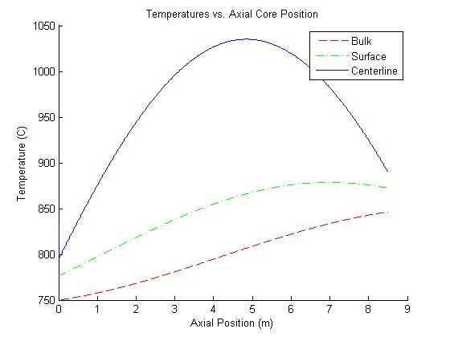

**Figure 4.6: Shows the centerline, surface, and bulk temperature in the core.**

Figure 4.7 shows the maximum centerline temperature for varying pebble radius. It can be seen that as the pebble radius increases, you reach a point where the change of the centerline temperature is minimal compared to the change in pebble radius.

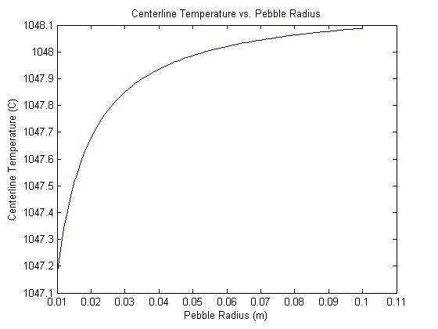

**Figure 4.7: Shows the centerline temperature as a function of variable pebble radius**

**4.1d Shutdown Heat Transfer**

To have a complete heat transfer analysis of the reactor, it must be analyzed in a shutdown situation. One of the most appealing characteristics of using a helium coolant is that it is excellent under emergency situations. An HTGR can be left alone for two days at shutdown before action must be taken.13 Since the specific heat is almost double graphite’s, it is safe to assume that the shutdown can be left alone at a minimum of the same time.44

Helium has many characteristics that make it appealing for emergency situations. One of the primary reasons is that the helium is a poor absorber of neutrons. Thus, if the helium leaks, it will not release much radioactivity into the environment because it will not be activated from the incident neutrons.

Passive heat removal for a helium-cooled HTGR is possible through conduction. The decay removal will dissipate through natural convection and radiative heat transfer. In addition, a low power density is needed. Figure 4.8 below shows the heat removal under a shutdown situation.13



**Figure 4.10: Depicts the heat transfer under a shutdown situation. *NOTE*: the figure displays a center reflector, which is not being implemented in the design. 13**

**4.2 Secondary Loop**

Due to the fact that HTGRs operate at such high temperatures, one must use a high temperature power conversion cycle. One cycle that meets this requirement is the Brayton Cycle, which is implemented in this design. Figure 4.9 shows a common Brayton Cycle in terms of pressure versus volume, and temperature versus entropy.30

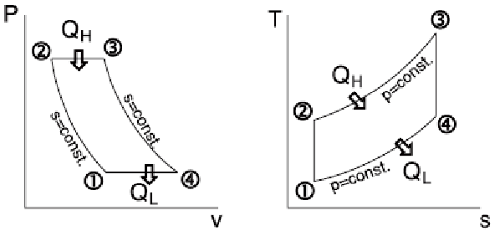

**Figure 4.9: Typical Brayton Cycle P-v and T-s diagrams.**Univ.of Waterloo,30.

A Brayton Cycle is quite similar to a Rankine Cycle, except instead of using liquids, the Brayton Cycle uses ideal gases and no phase change. With helium previously chosen as the coolant, the design implements a Brayton cycle for higher efficiency. The Rankine cycle is impractical due to the critical temperature of water being below the output temperature of the reactor. At an operating temperature of 900°C, the efficiency of a Brayton Cycle is known to be 49%, as compared to 32% for today’s LWR’s. 31

One other aspect of a Brayton Cycle that makes it significant to this design is the ability to add stages of intercoolers, reheaters, and regenerators in order to even further improve the efficiency of the system. Intercooling is done intermittently in the compression cycle. If the compressor is separated into a high and low pressure stage, where gas is cooled between those two stages, then one decreases the amount of the work that is needed in order to compress the gas. A typical intercooler design, as well as a T-s diagram is shown in Figure 4.10.

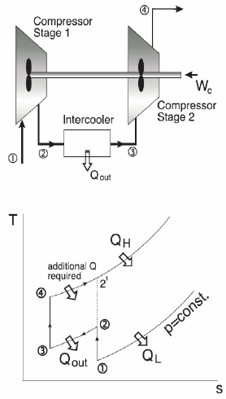

**Figure 4.10: A typical Brayton Cycle with intercooling, and its T-s diagram**Lane,31

Similarly, the process of reheating is done in the turbine side of the cycle. When the turbine is split into high and low stages of pressure, the subsequent heating happens between the two stages that the amount of work the turbine is capable of producing is increased. A typical reheater along with its T-s diagram is shown in Figure 4.11.31

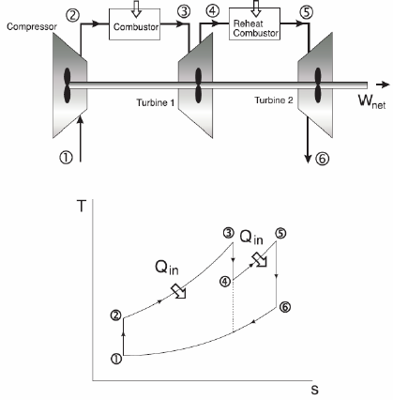

**Figure 4.11: A typical Brayton Cycle with reheating, and its T-s diagram.** Lane,31.

Regeneration is desired due to the fact that the gas exiting the turbine is typically hotter than the gas leaving the compressor. That being said, after the compressor raises the pressure of the gas, the gas passes through a heat-exchanger with the hot exit gases created by the turbine. If regeneration is not used in the system then the exit heat is simply wasted into the surrounding environment. A standard regeneration cycle as well as its T-s diagram is shown in Figure 4.12.31

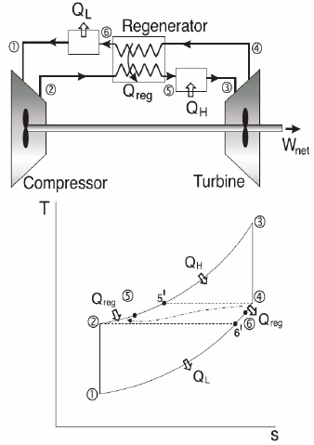

**Figure 4.12: Conventional regeneration cycle along with a T-s analysis.**Lane,31

For the project design, a large portion of the output heat to be used for hydrogen production. In particular, we aim to have 50% hydrogen production and 50% for electricity. In order for this to occur, excess heat simply has to be taken to one of the plants on site and be used to produce hydrocarbons products. At the present time, nearly all of the hydrogen produced in the United States comes from steam reforming of natural gas, which for now will remain the dominant method.32

Another method of hydrogen production, which is more environmentally favorable, is using the process of electrolysis. The power that is generated by the reactor is used for high temperature electrolysis which separates a molecule of water into its component parts of hydrogen and oxygen. Although this is quite an efficient and safe form of hydrogen production, this method is still only being used on a small scale as it has not received widespread acceptance.32

**Section 5: Disadvantages**

When examining a reactor system, it is beneficial to also examine the disadvantages to identify possible design improvements. The nuclear energy industry revolves around a defense-in-depth concept which gives way to redundant safety systems for the facility to remain safe in all plausible situations. Three major areas within the nuclear industry that require further research and improvement include: cost, nonproliferation, and nuclear material storage. Vast amounts of research is currently being implemented to improve these areas, in hopes that nuclear energy will surpass other electricity producers (e.g. natural gas, coal, oil) as the most viable source of clean, efficient, and safe power in the future.

The PBR design shares some of previously discussed flaws. As the chosen reflector, silicon carbide is more expensive to manufacture and use when compared to the more common graphite composite. The standard manufacturing process involves combining silica sand and carbon in an Acheson graphite electric resistance furnace at high temperatures, between 1600 and 2500 °C.45 Along with the reflector materials, the pebble fuel elements can become costly as well. The majority of the nuclear power industry use fuel rods as the design for the fuel inside the core, thus manufacturing a new spherical-shaped fuel element with small fuel TRISO fuel particles inside become an additional expense.

Additionally, all piping and system materials must meet safety regulations at the very high temperatures of operation. The melting point of these materials must be well above the operation temperatures (outlet temperature of ~1000 °C). All parts of the system must be air tight, due to the coolant with the system being in a gas (e.g. Helium).37

A key feature of the pebble-bed design is to create a lower power density core, thus giving a need for a core of high volume. In return the amount of contaminated waste increases, incurring high disposal costs.38 Furthermore, due to the high number of pebble fuel particles used in the reactor core, there is an increased probability of defect within a fuel particle.39 Figure 5.1 below illustrates a defect that occurred during manufacturing of a fuel particle.

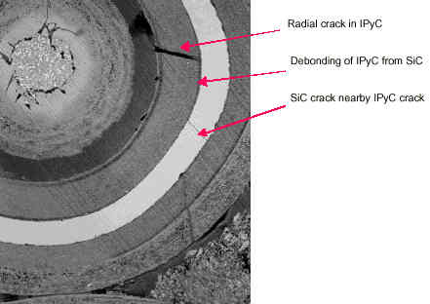

**Figure 5.1: Example of a defective pebble fuel particle.**Yoshiaki,39

**Section 6: Economics**

Economics will be an essential factor in driving the development of a low enrichment HTGR. As with other nuclear reactors the cost is primarily upfront, however after the initial investment nuclear begins to pay off. This effect can be seen in Figure 6.1 from the Nuclear Energy Institute (NEI).

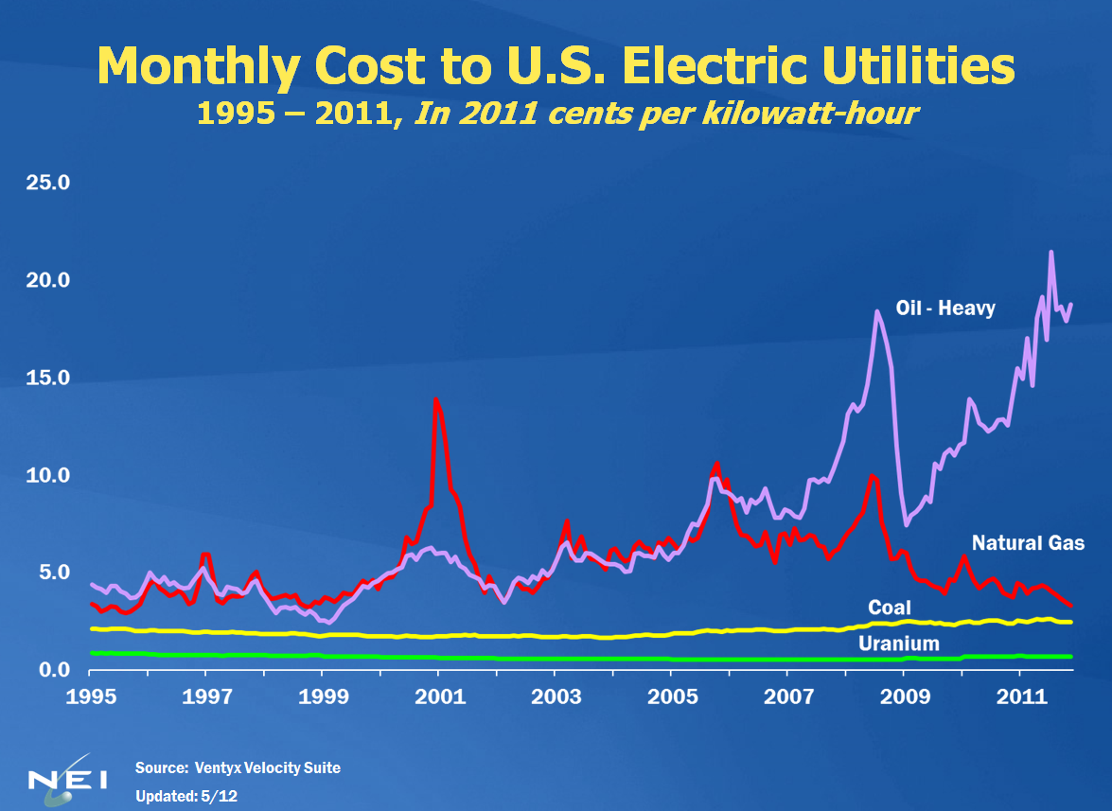

**Figure 6.1: Comparative monthly operation costs for U.S. Electric Utilities.40**

The NEI estimate applies to general uranium costs, but even within the nuclear sector, a low enrichment HTGR offers advantages over the traditional LWR. Fuel cost estimates for pebble fuel vary widely, but the high end estimates list approximately $30,000/kgU.43 This estimate along with other assumptions to fit a low enrichment HTGR give a value of 3.3 cents/kwhr. Compared to an LWR estimate of 3.8 cents/kwhr, the HTGR is about 13% cheaper to run than the average LWR.41

Another cost to address is the cost of SiC and BeO, both primary components in the low enrichment HTGR design. SiC possesses an economic advantage over graphite as a reflector material because it is cheaper. BeO powder is sold for approximately 900-1000 dollars per kilogram. Although it is costly to produce, the benefits of BeO will be realized economically through a lower required fuel enrichment due to more efficient moderation.

**Conclusion**

The outcome of the low enrichment HTGR presents very promising results. Utilizing the moderating mechanisms of changing the fuel pebble materials (e.g. BeO layer), as well as utilizing a silicon carbide reflector, and increasing the pressure of helium to 3atm allowed for the enrichment to be lowered to 5%, almost identical to what is currently being used in the current light water reactors. In addition, the results show that a change to beryllium oxide in the fuel will allow for the reactor to be increased above 1000 MWth and still be in a desirable temperature range. Using the characteristics of the low enrichment HTGR, it possible to use 50% to create power and the other 50% power for hydrocarbon production. If the price of the components can be reduced to a viable level and mechanisms to lower enrichment are further researched, commercial use of a low enrichment HTGR is a very real possibility in for the future nuclear industry. Table 7.1 summarizes the results of the design along with operating parameters.

**Table 7.1: Design Project Parameters.**

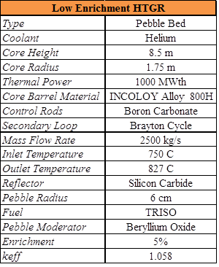

**Future Work**

A high temperature gas reactor shows potential for being a good candidate for the next generation of nuclear reactors in the United States. However, there are some areas that still need future research, especially with a design to lower enrichment, before it can be implemented. The key to lowering enrichment is increasing the moderation of neutrons to induce fission. The research team was able to employ some novel ideas in the design decrease the necessary enrichment of the fuel in the core. However, there were plenty of other ideas desired to be tested that introduced too many variables to analyze under the given time frame.

One way the design project could have seen some noticeable reduction in the enrichment is to introduce a silicon carbide reflector in the center of the core barrel to help moderate the neutrons. It was deemed too complicated as adding a reflector in the core would complicate the design, significantly increasing the difficulty of programming the SCALE, MCNP, and heat transfer model. Furthermore, the authors would have liked to test the effects of online refueling and burn up over the lifetime of the reactor on the enrichment of the fuel implemented in this design.

One of the key areas hindering the implementation of HTGR’s is materials. The mechanical properties of the core were analyzed at a 1% deformation, due to the available data does not allow a method to calculate creep at a lower deformation than this. Additionally, the strength of the materials are barely on the cusp of being able to operate a reactor for the average life desired, which is one area that needs to be improved upon. Improving the material strength will also allow the pressure of the helium to be increased which, in return, will further increase the moderation of the neutrons. The reactor core seemed to be over moderated after the analysis of reflector using SCALE. Under the time crunch presented, further analysis of the reactor without the reflector should be examined to identify if the keff  varies (i.e. neutron economy).

The final aspect that the research team would have liked to analyze is using more than one size of pebble in the reactor core. Using multiple pebble sizes would allow for a better packing fraction, and thus improve the final outcome of the analysis. However, this was not the crux of the research and would have also introduced too much complication to the current investigation of a low enrichment HTGR.

**References**

1. Nuclear Engineering Division. N.d. Graphic. Argonna National LaboratoryWeb. 1 Apr 2013. <http://www.ne.anl.gov/>.
2. Pebble Bed Reactor. Diss. Princeton University, Princeton, NJ: Princeton Press, Web. <https://www.princeton.edu/~achaney/tmve/wiki100k/docs/Pebble_bed_reactor.html>.
3. Pebble Bed Fuel Spheres Ship for Testing. 2009. Photograph. n.p. Web. 7 Apr 2013. <http://djysrv.blogspot.com/2009/09/pebble-bed-fuel-spheres-ship-for.html>.
4. "Gas Cooled Reactors." *The Virtual Nuclear Tourist*. Nuclear Tourist, 13 Apr 2009. Web. 8 Apr 2013. <http://www.nucleartourist.com/type/gcr.htm>.
5. "China's Tsinghua University Pebble Modular Reactor." . Professional Reactor Operator Society, 18 Oct 2008. Web. 4 Apr 2013. <http://www.nucpros.com/node/5220>.
6. "Current status and future development of modular high temperature gas cooled reactor technology." IAEA, n.d. Web. 2 Apr 2013. <http://www-pub.iaea.org/MTCD/Publications/PDF/te_1198_prn.pdf >.
7. Jenny Weil, Pebble-Bed Design Returns, in IEEE Spectrum, November 2001, pg. 37 - 40.
8. “PBMR Postponed.” World Nuclear News, 11 September 2009. < <http://www.world-nuclear-news.org/NN-PBMR_postponed-1109092.html>>
9. Ensor, Linda. "Hogan ends pebble bed reactor project." Business Day Live. N.p., 17 Sep 2010. Web. 3 Apr 2013.
10. Special Metals.  Incoloy Alloy 800H & 800HT.  Special Metals Corporation - Publication Number SMC-047.  04 Sept 2004.
11. C. Wang, “Design, Analysis and Optimization of the Power Conversion System for the Modular Pebble Bed Reactor System,” MIT Nuclear Engineering Department, Ph.D. Thesis, August 31, 2003.
12. United States Nuclear Regulatory Commissions. Reflector. NRC Library. 10 December 2012. Accuratus. Silicon Carbide, SiC Material Properties. http://accuratus.com/silicar.html. 4 April 2013.
13. Ball, Syd. Modular High Temperature Gas-cooled Reactors (HTGRs). Oak Ridge National Laboratory. 16 Jan. 2013.
14. Snead, Lance L. Composites for Nuclear Application. Oak Ridge National Laboratory. 20 March 2013.
15. Chilton, Arthur B., J. Kenneth. Shultis, and Richard E. Faw. Principles of Radiation Shielding. Englewood Cliffs, N Prentice-Hall, 1984.
16. Tomberlin, T.A. Beryllium – A Unique Material In Nuclear Applications. Idaho National Engineering and Environmental Laboratory. 15 November 2004.
17. Kotah, Y et al. Assessment of Silicon Carbide Composites for Advanced Salt-Cooled Reactors. Oak Ridge National Laboratory. September 2007.
18. Price, M. S. T. (2012). "The Dragon Project origins, achievements and legacies". Nucl. Eng. Design 251: 60–68.
19. “HTGR Mechanistic Source Terms White Paper,” INL/EXT-10-17997, Idaho National Laboratory Next Generation Nuclear Plant Project, July 2010.
20. "TRISO Fuel Design, Properties, and Requirements." INL. Idaho National Laboratory, 22 Dec 2010. Web. 12 Mar 2013.
21. Makhijani, Arjun and Michele Boyd, “Small Modular Reactors: No Solution for the Cost, Safety, and Waste Problems of the Nuclear Power.” Institute for Energy and Environmental Research. September 2010.
22. "Metalizing Ceramics Are Available for Beryllium Oxide Discs." ThomasNet.com News. N.p., 09 Aug. 2002. Web. 04 Apr. 2013.
23. “Scale 6.1 Manual.” Oak Ridge National Laboratory. Radiation Safety Information Computational Center (RSICC). 10 April 2013.
24. Stellar Industries. Beryllium Oxide Substrates. Products & Services: Ceramics. 8 April 2013.
25. “Nuclear Energy.” General Atomic, 1 Apr 2013. Web. 1 Mar 2013. <http://www.ga.com/nuclear-energy>.
26. Reitsma, Frederik. Thermal Fluid Characteristics for Pebble Bed HTGRs. IAEA, Beijing, China. 22 Oct. 2012.
27. de Zwaan, S. J., The Liquid Salt Pebble Bed Reactor : A New High Temperature

Reactor, Delft University of Technology M. Sc. Thesis, The Netherlands, Nov.2005.

1. Ruggles, A.E., Flow in Packed Beds.
2. Strydom, Gerhard et. al. The PBMR Steady State and Coupled Kinetics Core Thermal-Hydraulics Benchmark Test Problems. Beijing, China. 24 September 2004.
3. Microelectronics Heat Transfer Laboratory, University of Waterloo. “Brayton Cycle” <http://[www.mhtl.uwaterloo.ca/courses/me354/lectures/pdffiles/ch8.pdf](http://www.mhtl.uwaterloo.ca/courses/me354/lectures/pdffiles/ch8.pdf)>
4. Lane, Denise. “The Brayton Cycle with Regeneration, Intercooling, and Reheating.” 2001.<http://web.me.unr.edu/me372/Spring2001/The%20Brayton%20Cycle%20with%20Regeneration.pdf#search='the%20brayton%20cycle%20with%20intercooling>
5. de Zwaan, S.J.. “The Liquid Salt Pebble Bed Reactor.” Delft University of Technology. 2005.
6. "THE PBMR'S SAFETY FEATURES." PBMR,Inc. NRC. Web. 9 Apr 2013. <http://pbadupws.nrc.gov/docs/ML0310/ML031000208.pdf>.
7. Savkina, Marina. "Probabilistic Accident Analysis of the Pebble Bed Modular Reactor for Use with Risk Informed Regulation." Massachusetts Institute of Technology. MIT, n.d. Web. 9 Apr 2013. <http://dspace.mit.edu/bitstream/handle/1721.1/17748/56504086.pdf?sequence=1>.
8. "Auxiliary Systems." PBMR,Inc. NRC, n.d. Web. 9 Apr 2013. <http://pbadupws.nrc.gov/docs/ML0606/ML060680134.pdf>.
9. Harris, Gary Lynn . [*Properties of silicon carbide*](http://books.google.com/?id=Yy_B8GzxNlgC&printsec=frontcover). June 1995. IET. p. 19; 170–180. [ISBN](http://en.wikipedia.org/wiki/International_Standard_Book_Number) [0-85296-870-1](http://en.wikipedia.org/wiki/Special:BookSources/0-85296-870-1).
10. Steve Thomas, . "The Demise of Pebble Bed Modular Reactor." Bulletin of Atomic Scientist, 22 Jun 2009. Web. 3 Apr 2013. <http://www.thebulletin.org/web-edition/features/the-demise-of-the-pebble-bed-modular-reactor>.
11. Andrew C. Kadak, Ph.D., *The MIT Modular Pebble Bed Reactor Project*, March 19, 2001
12. Yoshiaki Ichihara, A Perspective on Nuclear Power Generation in the Future Electric Power Industry - For Nonspecialists in the Electric Power Related Industries, in Proceedings of the IEEE, Vol. 89, No. 12, December 2001.
13. “Nuclear Energy Resources and Statistics.” Nuclear Energy Institute (NEI). 6 Apr 2013. <http://www.nei.org/resourcesandstats/>
14. Kadak, Andrew. “A Future For Nuclear Energy – Pebble Bed Reactors.” MIT. 25 Apr 2005. <http://web.mit.edu/pebble-bed/papers1_files/PBReactors.pdf>
15. “Costs and Relative Costs for Selected Engineering Materials”. WebText. 4 Apr 2013. <http://mehr.sharif.ir/~amirkhani/textbook/app-c.pdf>
16. Grubert, Emily, and Brian Parks. "Pebble Bed Modular Reactors Versus Other Generation Technologies: Costs and Challenges for South Africa." Proc. of Global 2011, Japan, Makuhari.
17. Grossbeck, Martin L. Ph.D. University of Tennessee. Private conversation. 22 Apr 2013.
18. Vlasov, A.S. (1991). *Refractories and Industrial Ceramics* 32. p. 1083.

**Appendix**

***MATLAB Code: Creep***

% NE 472 Mechanical Properties of INCOLOY alloy 800H

% Trey Huffine

%

%%%%%%%%%%%%%%%%%%%%%%%%%%%%%%%%%%%%%%%%%%%

%

% Must use MKS units

%

%%%%%%%%%%%%%%%%%%%%%%%%%%%%%%%%%%%%%%%%%%%

close all, clear all, clc;

%% Variables

creep_percent = 10; % Total creep

P1 = 101325;

P2 = 2*P1;

P3 = 3*P1;

Diameter = 5; % diameter of core

time1 = 30*365*24 % time - converting years to hours

time2 = 40*365*24

time3 = 50*365*24

creep_rate1 = creep_percent/time1 % creep per hour

creep_rate2 = creep_percent/time2

creep_rate3 = creep_percent/time3

stress1 = 6.3*10^6; % Stress in Pa from Special Metals

stress2 = 5.5*10^6;

stress3 = 4.95*10^6;

% at 1 ATM

thickness1 = P1*Diameter/(2*stress1) % in meters

thickness2 = P1*Diameter/(2*stress2)

thickness3 = P1*Diameter/(2*stress3)

thickin1 = thickness1*37.3701 % compare to thickness in inches

thickin2 = thickness2*37.3701

thickin3 = thickness3*37.3701

% at 2 ATM

thickness1 = P2*Diameter/(2*stress1) % in meters

thickness2 = P2*Diameter/(2*stress2)

thickness3 = P2*Diameter/(2*stress3)

thickin1 = thickness1*37.3701 % compare to thickness in inches

thickin2 = thickness2*37.3701

thickin3 = thickness3*37.3701

% at 3 ATM

thickness1 = P3*Diameter/(2*stress1) % in meters

thickness2 = P3*Diameter/(2*stress2)

thickness3 = P3*Diameter/(2*stress3)

thickin1 = thickness1*37.3701 % compare to thickness in inches

thickin2 = thickness2*37.3701

thickin3 = thickness3*37.3701

***MATLAB Code: Thermal Hydraulics***

% NE 472 HTGR Helium Heat Transfer Code

% Trey Huffine

% Resources Consulted: Hobbs - "Liquid Salt Cooled Pebble Bed Reactor"

% Hetzler - "Liquid Salt Cooled Pebble Bed Reactor"

%

%%

close all, clear all, clc;

% Dimensions and mesh of core

diam_reactor = 1.75*2 ; %reactor vessel diameter in meters

h_reactor = 8.5 ; %reactor vessel height in meters

EB = 1.4*h_reactor ; % extrpolated boundary coordinate for reactor

n = 500 ; % number of axial mesh points

deltaz = h_reactor/n ; %axial spatial step

% Fuel Dimensions

diam_fuel = 0.06; %diameter of fuel sphere in meters

diam_fuel_innner = 0.0375

rad_fuel_inner = diam_fuel_innner/2 ; %interior radius of the fuel

rad_fuel_out = diam_fuel/2 ; %exterior radius of the fuel

%Properties and Flow

Kpc = 280; %thermal conductivity of BeO

Kfuel = 23 ; %thermal conductivity of fuel region

Q_reactor = 1000*10^6; % heat generation in reactor in watts

mdot = 10000 ; % mass flow rate of helium in reactor kg/sec at 100% power

% Thermophysical Properties Helium Using Average Temperature

% Source - Danish Atomic Energy Comission

T_op = 500 %steady state operating temperature deg C Top -> T operating

T_abs = T_op + 273.15 ;

P_calc = 1.01325*3; % Must be in bars for equation

%Khel = (.635*10^-3+.31*10^-3*T_abs-.244*10^-7*T_abs^2)

Khel = 2.682*10^-3*(1+1.123*10^-3*P_calc)*T_abs^(.71*(1-2*10^-4*P_calc))

Cp = 5193.1 ; % specific heat capacity of helium at 700 deg C

mu = 3.674*10^-7.*T_abs^.7 ; % viscosity of helium

rho_helium = 48.14*(P_calc/T_abs)*(1+.446*P_calc/(T_abs^1.2))^-1 % density of helium coolant

% Determination of Packing fraction of a close packed sphere using method

% cited in de Zwann

epsilon = 0.375 + 0.34*(diam_fuel/diam_reactor) ;

packing = 1-epsilon;

%Determination of the number of fuel pebbles in the reactor

Vol_reactor = (pi/2)*(diam_reactor^2)*h_reactor %total volume of reactor

Vol_pebbles = 4/3*pi*(diam_fuel/2)^3

Vol_usage = packing*Vol_reactor

npeb = Vol_usage/Vol_pebbles

%Characteristics of fuel in pebbles

fracfuel = (rad_fuel_inner^3)/ (rad_fuel_out^3) %volume fraction ratio in fuel pebble

Vfuel = (pi/4)*(diam_reactor^2)*deltaz*packing*fracfuel %volume of fuel in the reactor

% Setup for Heat transfer model provided by A.E. Ruggles

av = 6/diam_fuel;

a = packing*av;

v0 = mdot/((pi/4)*rho_helium*(diam_reactor)^2) %superficial velocity

%Pressure Drop

pressdropA = (150*mu*v0)/(diam_reactor^2)*(packing^2)/(epsilon^3);

pressdropB = ((1.75*rho_helium*v0^2)/diam_reactor)*(packing/epsilon^3);

pressdrop = (pressdropA + pressdropB)*h_reactor*10^-8 % ~300kpa

%Power of pump needed to overcome the pressure drop

Pumppower = (mdot/rho_helium)*pressdrop

perc_power = Pumppower / Q_reactor

%Q added

Q_adjusted = Q_reactor/((EB/pi)*(sin(pi*(h_reactor/(2*EB)))-sin(pi*(-1.0)*h_reactor/(2*EB)))) ;

%Volumetric heat generation at middle of reactor

%Calculates axial dimensioning and peaking power

T_bulk(1) = T_op ; % bulk temperature at the bottom of the core

z(1) = 0 ; % initializes coordinate as starting at the bottom of core

Re = (rho_helium*v0)/(a*mu) %Reynolds number

if (Re < 50*10^4)

h_helium = (Cp.*rho_helium.*v0).*(Khel/(mu*Cp))^(0.6666).*0.91.*(Re)^(-1.0.*0.51) % check units here

else

h_helium = (Cp.*rho_helium.*v0).*(Khel/(mu*Cp))^(0.6666).*0.61.*(Re)^(-1.0.*0.41)

end

%Initialize values

Q_current(1) = Q_adjusted*cos(pi*(z(1)- h_reactor/2 + deltaz/2)/EB);

Q_added(1) = Q_current(1)*deltaz;

T_surface(1) = T_bulk(1) + Q_added(1)/(h_helium*a*(pi/4)*(diam_reactor^2)*deltaz);

Q_tp(1) = Q_added(1)/(Vfuel);

Tcla(1) = T_surface(1) + Q_tp(1)*((rad_fuel_inner^3)/(3*Kpc))*(1/rad_fuel_inner-1/rad_fuel_out);

Tclb(1) = (Q_tp(1)/(6*Kfuel))*(rad_fuel_inner^2);

Tcl(1) = Tcla(1) + Tclb(1);

%Numerical Analysis of temperatures

for (i = 2:(n))

z(i) = z(i-1) + deltaz; % current height slice

Q_current(i) = Q_adjusted*cos(pi*(z(i)- h_reactor/2 + deltaz/2)/EB);

Q_added(i) = Q_current(i)*deltaz;

T_bulk(i) = T_bulk(i-1) + Q_added(i)/(mdot*Cp);

T_surface(i) = T_bulk(i) + Q_added(i)/(h_helium*a*((pi/4)*diam_reactor^2)*deltaz);

Q_tp(i) = Q_added(i)/(Vfuel);

Tcla(i) = T_surface(i) + Q_tp(i)*((rad_fuel_inner^3)/(3*Kpc))*(1/rad_fuel_inner-1/rad_fuel_out);

Tclb(i) = (Q_tp(i)/(6*Kfuel))*(rad_fuel_inner^2);

Tcl(i) = Tcla(i) + Tclb(i);

end

Tcl(250)

%plot for global temperatures

figure (1)

hold on

plot(z,T_bulk,'--r')

plot(z,T_surface,'-.g')

plot(z,Tcl)

legend('Bulk', 'Surface', 'Centerline')

title('Temperatures vs. Axial Core Position')

xlabel('Axial Position (m)')

ylabel('Temperature (C)')

%Differential pressure change will changing diameter

dr = [];

Pump_pow = [];

n = 1;

press_drop = [];

pp = [];

for k=1:.1:10

dr(n) = k;

eps = 0.375 + 0.34.*(diam_fuel./dr(n)) ;

pack = 1-eps;

v_0 = mdot./((pi./4).*rho_helium.*(dr(n)).^2);

pdA = (150.*mu.*v_0)./(dr(n).^2).*(pack.^2)./(eps.^3);

pdB = ((1.75.*rho_helium.*v_0.^2)./dr(n)).*(pack./eps.^3);

press_drop(n) = (pdA + pdB).*h_reactor.*10.^-8;

Pump_pow(n) = (mdot./rho_helium).*press_drop(n);

pp(n) = Pump_pow(n) / Q_reactor*1000;

n=n+1;

end

figure (2)

plot(dr,pp)

title('Pump Power Percent vs. Differential Core Diamter')

xlabel('Core Diameter (m)')

ylabel('Pump Power Percent (%)')

figure (3)

plot(dr,press_drop)

title('Pressure Drop vs. Differential Core Diamter')

xlabel('Core Diameter (m)')

ylabel('Pressure Drop (kPa)')

%Differential pressure change will changing diameter

dh = [];

Pump_pow = [];

n = 1;

press_drop = [];

pp = [];

for k=1:.1:15

dh(n) = k;

eps = 0.375 + 0.34.*(diam_fuel./diam_reactor) ;

pack = 1-eps;

v_0 = mdot./((pi./4).*rho_helium.*(diam_reactor).^2);

pdA = (150.*mu.*v_0)./(diam_reactor.^2).*(pack.^2)./(eps.^3);

pdB = ((1.75.*rho_helium.*v_0.^2)./diam_reactor).*(pack./eps.^3);

press_drop(n) = (pdA + pdB).*dh(n).*10.^-7;

Pump_pow(n) = (mdot./rho_helium).*press_drop(n);

pp(n) = Pump_pow(n) / Q_reactor*1000;

n=n+1;

end

figure (4)

plot(dh,pp)

title('Pump Power Percent vs. Differential Core Height')

xlabel('Core Height (m)')

ylabel('Pump Power Percent (%)')

figure (5)

plot(dh,press_drop)

title('Pressure Drop vs. Differential Core Height')

xlabel('Core Height (m)')

ylabel('Pressure Drop (kPa)')

% Differential radial Tcl

R_diff = .01:.001:.1; % 1-10cm

for i=1:length(R_diff)

Tcla_diff = T_surface(500) + Q_added(500)*((rad_fuel_inner^3)/(3*Kpc))*(1/rad_fuel_inner-1/R_diff(i));

Tclb_diff = (Q_added(500)/(6*Kfuel))*(rad_fuel_inner^2);

Tcl_diff(i) = (Tcla_diff + Tclb_diff)*1.85;

end

figure (6)

plot(R_diff,Tcl_diff)

title('Centerline Temperature vs. Pebble Radius')

xlabel('Pebble Radius (m)')

ylabel('Centerline Temperature (C)')

**Sample SCALE Code: Keff Calculations**

=csas25 parm=(centrm)  
HighTemperatureGasCooledPebbleBedReactor  
v6-238  
   
read comp  
  
'Silcon Carbide Reflector:  
Si 1 .70045 300 end  
C  1  .29955 300 end  
  
'Stainless Steel Shell:  
ss304 2 1 300 end  
  
  
'Oak Ridge Concrete:  
orconcrete 3 1 300 end  
  
  
'Helium:  
 he  5  den=0.1892 1 300 end  
   
'Helium in fuel region:  
  
he          89 den=0.1892 1 300 end  
    
'fuel kernel, 5% 235:    
 uo2         91 den=10.41 1 300 92234 0.005407837 92235 5 92238 84.99459 end  
   
  
'1st Fuel Coating:   
 c-graphite  101 0 0.056255 300 end  
   
   
'2nd Fuel coating:   
 c-graphite  102 0 0.095714 300 end  
   
   
'3rd Fuel coating:   
 c-graphite  103 0 0.048136 300 end     
 si          103 0 0.048136 300 end  
   
'4th Fuel coating:   
 c-graphite  104 0 0.093759 300 end    
  
'center graphite matrix:   
beryllium         99 .36032 300 end  
o-16         99 .63968 300 end  
  
'Pebble Cladding:   
beryllium         98 .36032 300 end  
o-16         98 .63968 300 end  
   
end comp  
read celldata    
doublehet fuelmix=82 end  
        gfr=0.02985 91 coatr=0.03588 101 coatr=0.038945 102 coatr=0.041835 103 coatr=0.04645 104 VF=0.1167 matrix=98 end grain   
        pebble sphtriangp right_bdy=white hpitch=3.6 89 fuelr=2.5 cladr=3.5 99 end   
end celldata  
read parameter   
           gen=200   
           npg=1000   
           NSK=10   
           FLX=yes   
           FDN=yes   
           PKI=yes   
           FAR=yes   
           GAS=yes   
           FMP=yes   
           MKU=yes   
           FMU=yes   
           SMU=yes   
           NUB=yes   
           CFX=yes   
end parameter  
read geometry  
Global Unit 1  
 cylinder 82 1 175 700  0  
 cylinder 5 1 175 850 0  
 cylinder 1 1 230 905 -55  
 cylinder 2 1 240 915 -65  
 cuboid 5 1 1000 -1000 1000 -1000 1500 -500  
 cuboid 3 1 1100 -1100  1100 -1100 1600 -600  
end geometry  
end data  
end